Data Modeling Document
Objective:
The objective of this analysis is to evaluate the existing data sets, identify gaps that may impact reporting requirements, and propose a data model that supports accurate and scalable analytical use cases.
Key Findings from raw-data validations:
- All customers referenced in the order dataset have valid corresponding records in the customer dataset, indicating referential integrity between these two tables.
- Shipping data is associated at the customer level and does not have a direct relationship with individual orders.
- Multiple shipping records exist per customer, making it difficult to associate shipments with specific orders accurately.
- A total of 98 shipping records across 55 customers do not have corresponding order records, representing orphan shipping records with no associated transactions.
- Order data does not include quantity information for product-level aggregation.
- Shipping data lacks event-level timestamps such as shipment start date and delivery date, limiting the ability to track the shipment lifecycle.
- In 6 cases, customers have more ‘Delivered’ shipping records than total orders, indicating potential data inconsistency or duplication in shipment events.
- No direct mapping exists between order_id and shipping_id, preventing accurate assignment of delivery status at the order level.
- Each shipping_id is associated with a single status, indicating that shipment records represent discrete events rather than a full shipment lifecycle.
Impact on business:
- It is not possible to accurately determine delivery status at the order level due to a lack of direct linkage between orders and shipping.
- Aggregations such as total amount for pending deliveries may be incorrect if based on ambiguous relationships.
- Product-level and customer-level analyses may be limited due to missing attributes such as quantity and timestamps.
Requirements for anticipated datasets:
- Implement a Slowly Changing Dimension (Type 2) for the customer dataset by introducing valid_from_date and valid_to_date fields, along with a current_record_flag. This will enable tracking of historical changes in customer attributes such as country or location. For active records, the valid_to_date can be set to a default high value (e.g., '9999-12-31') and current_record_flag set to 'Y'. When a change occurs, the existing record will be expired (valid_to_date updated and flag set to 'N') and a new record will be inserted with updated attributes.
- Introduce a surrogate key (customer_sk) in the customer dimension to be referenced in fact tables. This ensures accurate historical tracking of customer attributes at the time of the transaction.
- Create a Product dimension table to standardize product information. This table will contain product_id as the primary key along with product_name, and will be referenced in the order fact table to ensure consistency.
- Separate the order dataset into two structures to maintain proper grain:
- An fact-order table at the order level (one row per order), containing order_id, customer_sk, order_date, and total_amount.
- A product order table at the order-product level (one row per order-product), containing order_id, product_id, quantity, and amount. This enables accurate product-level and transactional analysis.
- Introduce a bridge table to map order_id and shipment_id, as there exists a many-to-many relationship between orders and shipments. This table will reference the Order Header table to ensure referential integrity and maintain correct grain alignment.
- Enhance the shipping dataset by introducing shipment_date and delivery_date fields to capture the shipment lifecycle. The delivery status can also be derived from the presence of delivery_date (e.g., NULL indicates pending, and non-NULL indicates delivered). Additionally, remove customer_id from the shipping dataset to ensure that shipments are correctly associated at the order level rather than the customer level.
Final Proposed Data Model:
The proposed data model follows a dimensional design approach, separating business processes into fact tables and descriptive attributes into dimension tables. This ensures clear relationships, accurate aggregation, and scalability for analytical reporting.

Dim_Customer(SCD Type 2)- Grain: One row per customer version (historical tracking)
customer_sk (PK) NUMBER Surrogate key
customer_id (business key) VARCHAR Customer ID
first_name VARCHAR Customer first name
last_name VARCHAR Customer last name
age NUMBER Customer age
country VARCHAR Customer country
valid_from_date DATE Indicates dates from when the record is valid
valid_to_date DATE Expiry date of the record
current_record_indicator VARCHAR(1) Current record indicator
Dim_Product - Grain: One row per product
product_id (pk) VARCHAR Product unique identifier
product_name VARCHAR Product name

Fact_Order_- Grain: One row per order
order_id (pk) VARCHAR Order ID
customer_sk (FK) NUMBER Unique customer identifier
order_date DATE Date when order was placed
Total_amount NUMBER(10,2) Total amount of the order
Fact_Product_Order- Grain: One row per order-product
order_id (FK) VARCHAR Order ID
product_id (FK) VARCHAR Product id
quantity NUMBER Quantity of products purchased
amount NUMBER(10,2) Total amount
Primary key: (order_id, product_id)

Fact_Shipping – Grain: One row per shipment
shipment_id (pk) VARCHAR Unique Identifier Shipping ID
shipment_date DATE Date when the item gets shipped
delivery_date DATE Delivery date
status VARCHAR Status of the shipment

Order_Shipment_Bridge – Grain : One row per order shipment
order_id (FK) VARCHAR Order id from Fact_order
shipment_id(FK) VARCHAR Shipping id
Primary key: (order_id, shipment_id)
ERD Diagram:
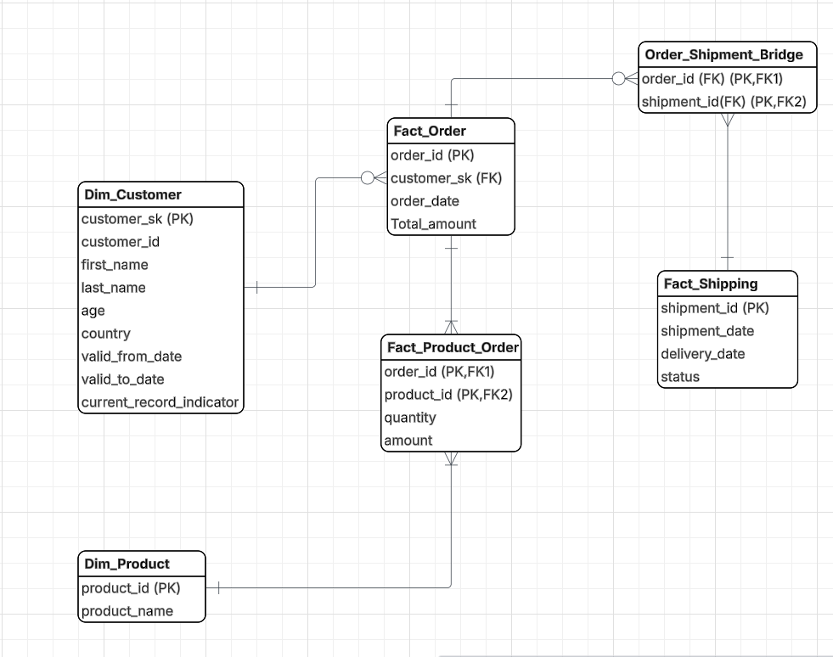
Final Relationship summary:
Dim_Customer (1) ----- (M) Fact_Order
Fact_Order (1) ------ (M) Fact_Product_Order
Dim_Product (1) ------ (M) Fact_Product_Order
Fact_Order (1) ------ (M) Order_shipment_bridge
Fact_Shipping (1) ------ (M) Order_shipment_bridge
Note: Bridge resolves MANY-to-MANY between Order and Shipping
Key points to remember:
- The separation of order data into fact_order and fact_product_order ensures correct grain and prevents duplication when dealing with product-level details.
- The customer dimension uses a surrogate key to support historical tracking of customer attributes through SCD Type 2 implementation.
- The shipping table captures the shipment lifecycle using shipment date and delivery date, with one record per shipment. The record is updated when a delivery occurs, and the delivery status can also be derived from the presence of a delivery date.
- A bridge table is introduced to accurately represent the many-to-many relationship between orders and shipments without duplicating fact data.
- This design ensures accurate aggregation, maintains data integrity, and provides flexibility to support all required business queries.

